Name:……………………………………………………………..

ID:…………………………………………………………………

*Exercise 1:* Estimation for Project A

Description:

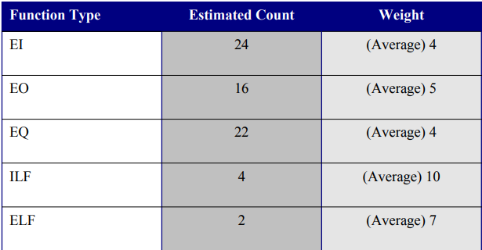

Calculate UFP?

*Exercise 2:* Estimation for Project B

Description:

|  |  |
| --- | --- |
| **External Inputs** | **Complexity** |
| Data Stream | High |
| Configuration files | Low |
| User Selection | Medium |
| User Input | Low |
| **External Output** | **Complexity** |
| Telemetry Data1 screen | Medium |
| Telemetry timing screen | Low |
| Telemetry Data2 Screen | Medium |
| Status Screen | Medium |
| **Internal Logical Files** | **Complexity** |
| Storage file | Medium |
| Intermediate buffer | High |
| Intermediate Result | Low |
| Channel Files | Low |
| **External Interface Files** | **Complexity** |
| External Interface for Data2 | Low |

**External Queries**

Not Any.

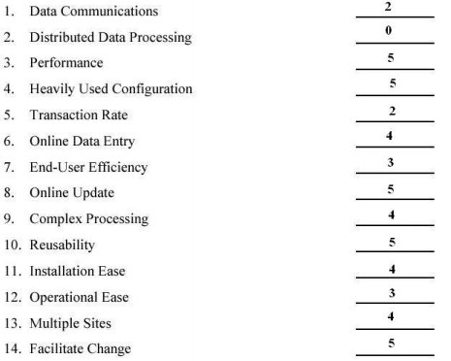

Calculate UFP, FP

*Exercise 4:* Estimation for Project D

Calculate the function score value for a project with the information field characteristic as follows:

- Input: 32

- Output: 60

- Inquiry: 24

- Logical file: 8

- External interface: 27

Assume all complexity adjustment values ​​are average. Calculate the feature point value under the same conditions.

Calculate FP

*Exercise 5:* Based on the functional score in Exercise 4, calculate the conductivity measures:

- Productivity

- Quality

- Cost

- Data

Of which: person = 12, month = 4, number of errors = 1000, total cost = $ 150,000,000, number of data pages = 200.

*Exercise 6:*

Assuming:

Estimated FP = 401

Organisation average productivity (similar project type) = 6.5 FP/p-m (person-month)

Burdened labour rate = 8000 $/p-m

Then

Estimated effort = ?

Cost per FP = ?

Project cost = ?